Douthart Scholarship Hall

Est. 1954

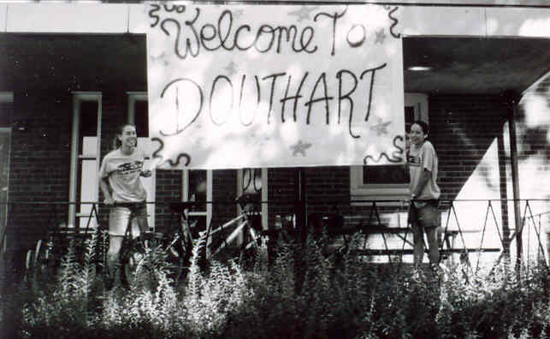

The Scholarship Halls:

- The University of Kansas Scholarship Halls offer a cooperative living situation that combines shifts and an active, involved living community. There are 5 men’s halls and 5 women’s halls. This creates a close community of 500 residents all interested in cooperative living and an involved college experience.

- Each resident is responsible for a shift each semester. A shift takes approximately 3-4 hours per week and ranges from cleaning a bathroom, cooking lunch once a week, cleaning common areas, and many other choices.

- Participating in the governance, maintenance, and upkeep of the hall is in exchange for the reduced housing cost (See the Department of Student Housing Handbook).

-The Scholarships Halls have the All Scholarship Hall Council, which is made up of representatives from all ten halls. This council discusses scholarship hall issues and sponsors programming and social events, which allow residents to meet people from each of the other nine halls. Visit its website at: www.ku.edu/~ashc

-Acceptance into the Scholarship Halls is through an application process. Residents are selected based on academic merit and ability to contribute actively to the cooperative and social spirit of communal living.

The Official Side of Douthart:

-Douthart houses 49 women, one of which is the Scholarship Hall Director (SHD) who oversees the maintenance of the hall, orders food, and advises the hall government. The hall also has a proctor, who monitors the completion of shifts.

-Douthart’s hall government is very active—working to improve the hall and provide social, educational, and community service events for residents. Examples of events are a social picnic or bonfire with one of the men’s halls, speakers on women’s health issues or topics pertaining to a specific major, and volunteering at the humane society.

-Four women occupy a suite. Each suite contains two bunkrooms, which has bunk beds, closets, and drawers. A common room is shared between the bunkrooms with four desks, and desk chairs. This room may be a study room or social room as determined by the four roommates.

-Douthart provides meals for breakfast, lunch, and dinner. Cooking is a part of the shifts assigned to residents. Douthart’s pantry is always open and residents are all free to use the kitchen and refrigerators. Laundry is also free and available at all times.

-Douthart has an escort policy and keypad coded entry so that residents always feel free to leave doors open and socialize within the hall without fear for the safety of their possessions or personal safety.

Douthart’s Social Side:

-All residents take an active role in the Douthart community. The hall has nearly 50 years of traditions from Red Bandana raids and candlelightings to Mardi Gras celebrations and the Winter Formal.

-At the beginning of each year returning women are paired up with new women for the Big / Lil’ Sis program. Each big sis helps her lil’ sis find her way around campus, buy books, and go on trips to Mass Street or Target. Big sisters help familiarize lil’ sisters with shifts and how the hall runs in addition to making meeting people easier for new women.

-Lots of in-hall events are held as study breaks and are good times to socialize with the other women in Douthart. Study breaks have ranged from tie dying and cookie baking to “How well do you know your roommate” games and dance parties.
-Douthart also holds many social events with the
other scholarship halls. These events range from a fall
cookout with a men’s hall to a Tropical Snow run or movie
night with another women’s hall.

-Douthart women also just like to hang out. You can always
find someone in the living room or out having a popsicle
and enjoying the weather on the front lawn.

Also visit the other women’s halls: Margaret Amini, Miller, Sellards, and Watkins.

